Introduction?
SOME (Simple Object Model Edit) is a "language" for designing object-oriented applications. It aims to be a simple alternative for UML (Unified Modeling Language).

SOME vs. UML
Like UML, SOME helps you design applications in an object-oriented way. It appears like a simple UML without diagrams. SOME has implemented two UML model types: Class model (SOME Roles) and Sequence model (SOME Stories). On the other hand, as a "language", SOME has a complete suite of language specifications. Here are some examples for describing the relations between SOME and UML:

Class diagram in UML:
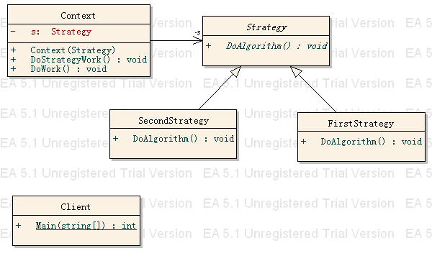

SOME Role declaration file (SMR)
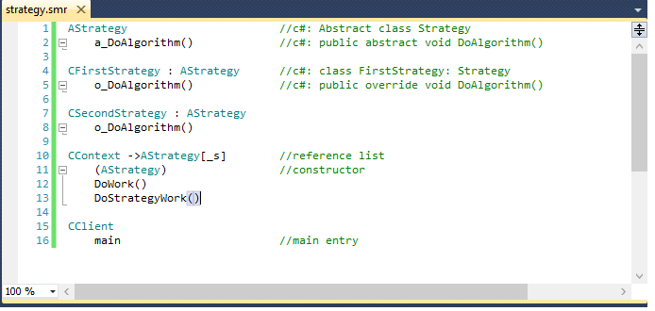

Sequence diagram in UML:
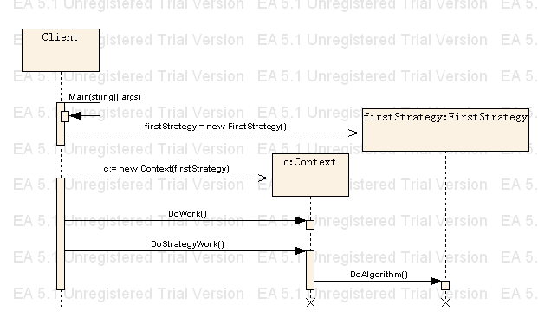
SOME Story file (SMS):
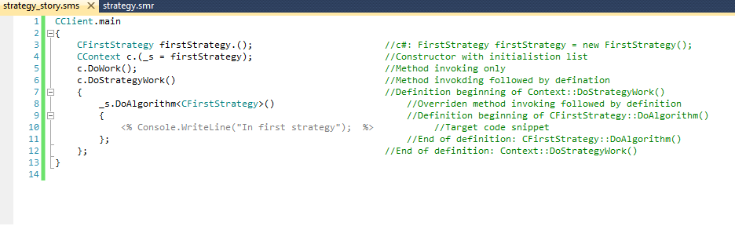

Code in c#:
abstract class Strategy
{
abstract public void DoAlgorithm();
}

class FirstStrategy : Strategy
{
override public void DoAlgorithm()
{
Console.WriteLine("In first strategy");
}
}

class SecondStrategy : Strategy
{
override public void DoAlgorithm()
{
Console.WriteLine("In second strategy");
}
}

class Context
{
Strategy s;
public Context(Strategy strat)
{
s = strat;
}

public void DoWork()
{
// some of the context's own code goes here
}

public void DoStrategyWork()
{
// now we can hand off to the strategy to do some
// more work
s.DoAlgorithm();
}
}

///<summary>
/// Summary description for Client.
///</summary>
public class Client
{
public static int Main(string[] args)
{
FirstStrategy firstStrategy = new FirstStrategy();
Context c = new Context(firstStrategy);
c.DoWork();
c.DoStrategyWork();

return 0;
}
}

Benefits (Why SOME?)

Simplicity
SOME can be regarded as a type of object-oriented pseudo-code, learning SOME is very easy if you are familiar with any other popular programming languages like C# or C++, Java. Unlike most languages, SOME does not have any keywords, instead, SOME uses some non-letter tokens such as '.', '->' or concatenating pre-defined prefix into identifier names to be part of a modifier. Please refer to the examples below(c#):
"CSample" is interpreted as "class Sample".
"o_Method()" is interpreted as "public override void Method()", capital M indicates this should be 'public'.
"int r_Length" is interpreted as a definition of a read-only Property:
private int _length;
public int Length
{
get{return _length};
}"
"CSample s<CSubSample>.();" is interpreted as "CSample s = new CSubSample();".
"obj;" is interpreted as "return obj;".

Readability
Unlike any popular object-oriented language, which sacrifices readability for maintainability, SOME Stories reflect actual software run-time events. Thanks to the simplicity, SOME is perfect as a design language which provides a very clear means of describing applications.

Code as documentation
SOME is an alternative for diagram-based documentation. Some people find it very frustrating to use CASE tools especially most them really haven't really saved time. Drawing class diagrams and sequence diagrams uses more time than writing actual code. Code masters rarely use a tool to draw diagrams, they draw them with a real pen on paper or whiteboards, because this saves time. Back to constructional programming ages, they mostly used pseudo-codes. Today we still have to draw design diagrams because of two major reasons: for designer himself to better review the design; for peers to leave a helpful documentation.
SOME is simple, so it no doubt saves time. It contains design models so it can be used as documentation itself. It can easily be translated into target source code so it can also be seen as the code itself. It is a pseudo-code standard for elite programmers.

SOMEOne Studio (Part of StoryTime Studio)
SOMEOne Studio is a tool supporting SOME coding, like most of other IDEs, it provides following features:
Language services: Syntax Colouring, Auto Completion, Code Outlining etc.
Code generation: C#/VB.Net/Java/C++
Solution and project supports.
